Schembl8394723
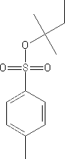
Main Function Group: Tertiary Tosylate
- Common Name – SCHEMBL8394723
- IUPAC Name – 2-Methylbutan-2-yl 4-methylbenzenesulfonate
- Molecular Weight – 242.34 g/mol
- Melting Point – N/A
- Boiling Point –N/A

